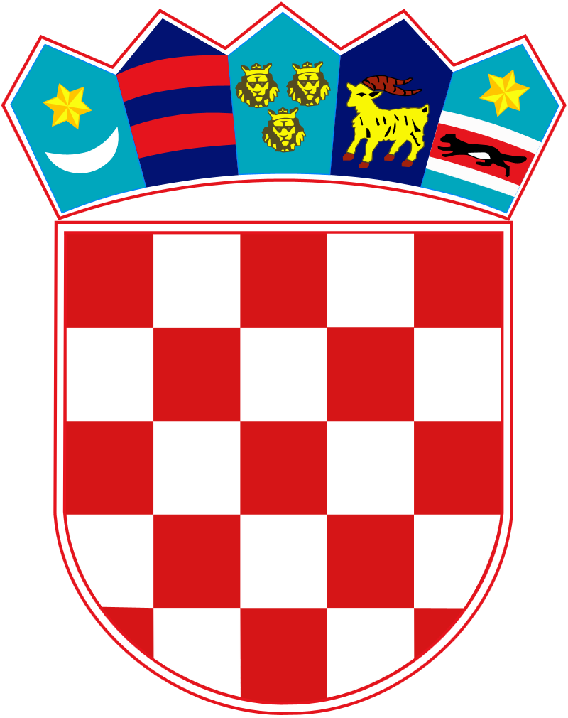
l

REPUBLIC OF CROATIA
CENTRAL STATE OFFICE FOR CROATS ABROAD

APPLICATION FORM

for the Award of Scholarships for Online Croatian Language Learning for the academic year 2023/24

Type of applicant:
(circle one of the following options)

- member of the Croatian Nation
- spouse of a member of the Croatian Nation
- friend of the Croatian people and the Republic of Croatia

Personal data:

Name

Surname

Gender (cricle) | M F
Date and place of birth

Crountry of birth

Nationality/ies

Mobile phone/Telephone

E-mail address

Number of travel document/s

Place and country of issue

Information of permanent/temporal residence:

 | Permanent residence¹ | Temporal residence²
Street and number
Place

Zip code

Country

¹ Data provided by identification document (ID card or passport)
² To be filled out only if the current address differs from the place of permanent residence

Acquired level of education:
(circle one of the following options)

a) highschool
b) tertiary
c) university

Period of attendance of the online course HiT-1:
(circle one of the following options)

- autumn semester (September, 11 - December 3, 2023)
- spring semester (March 4 - May 26, 2024)

Achievements and motivation of the candidate (brief description, max.1000 characters)

Under penalty of perjury, I vouch through my signature on this application form that I will immediately inform the Central State Office for Croats Abroad shall I be granted another scholarship financed by the state budget of the Republic of Croatia during the exercise of my rights granted by the scholarship for Online Croatian language learning for the academic year 2023/24.

Place and date:

___________________
signature

